VIZ1 – Session 7: Visualization Workshop
Dataset: boys.csv (boyband dataset)

1. DATA EXPLORATION

Use the boyband dataset. Explore the data, and find:

The dataset type: A static table of band-member records. It can be treated as a multidimensional table using band and name as a composite key. There are 234 records, 55 bands and 18 attributes.

The data types: Items are member records within bands; attributes describe each record. Band and name together identify a row. There are no explicit links, spatial positions or grids. Grouping by band and deriving counts does not make the original dataset a network.
Data checks: band + name is unique in this file, while name alone is not. Some artists appear under different band entries, so the unit is a member record, not necessarily a unique person. Bands contain 3-7 records: 12 bands of size 3, 21 of size 4, 19 of size 5, two of size 6 and one of size 7.
Ordering: dates and height are sequential; hair length runs short -> medium -> long. Recorded skin-tone labels have the order light -> medium-light -> medium -> medium-dark -> dark, without implying numerical distances or a ranking of people. Colour names have no inherent order. Birth month or conventional zodiac group can be derived as cyclic categories; the full birth date is not cyclic.
Data quality: bottom colour is complete (10 categories); shirt colour has one missing value and a patterned category; jacket colour has 117 missing values. Birth date is missing in 43 records and height in 115. hair_frosted includes green and red as well as yes/no. Do not equate missing with no, zero or a colour. Multi-valued attributes need splitting if analysed.
Scope: the records describe appearances, not a time series of outfits. Birth-year differences do not establish fashion change over time, and the sample cannot estimate the probability of joining a boyband. Numerical colour codes would not make colour names ordinal or define perceptual contrast.

(If applicable) The attribute types, including keys and values:

Attribute name | Attribute type | Key/Value | Ordering direction
band | Categorical | Key with name | Not applicable
name | Categorical | Key with band | Not applicable
dob | Quantitative (temporal) | Value | Sequential
hair_color | Categorical | Value | Not applicable
hair_frosted | Categorical (not Boolean) | Value | Not applicable
hair_length | Ordinal | Value | Sequential
hair_style | Categorical | Value | Not applicable
eyes | Categorical | Value | Not applicable
facial_hair | Categorical, multi-valued | Value | Not applicable
accessories | Categorical, multi-valued | Value | Not applicable
top_style | Categorical, multi-valued | Value | Not applicable
bottom_style | Categorical | Value | Not applicable
height | Quantitative | Value | Sequential
skin | Ordinal | Value | Sequential
instrument | Categorical | Value | Not applicable
shirt_color | Categorical | Value | Not applicable
jacket_color | Categorical | Value | Not applicable
bottom_color | Categorical | Value | Not applicable

2. GENERATE QUESTIONS

Generate as many exploratory questions as you can – at least 5.
Good keywords to lead to questions: Comparison, Distribution, Composition, Trend, Relationship, Ranking, Change, Outliers, Clusters

1. Which hair styles occur together with which facial-hair categories?
2. Does the distribution of hair_frosted categories differ across birth-year groups?
3. Which accessories are common among members in different birth-year groups?
4. How does the distribution of bottom_style differ across the recorded skin-tone categories?
5. How many member records does each band have, and which band sizes are most common?
6. Do bands cluster into overall looks, such as suits versus streetwear?
7. Do records with an alias in the name have different hair-style distributions from records without one? Alias identification would need an explicit rule.
8. How are the recorded birthdays distributed across the months or zodiac groups of the year?
9. Do larger bands use more distinct recorded clothing colours than smaller bands?
10. What is the relationship between band size and the uniformity of members' recorded clothing colours?

3. DEFINE YOUR VISUALIZATION QUESTION

Select one question:

How does band size relate to the share of member pairs wearing the same recorded bottom colour (0 = all different, 1 = all matching)?
- My visualization investigates whether recorded band size is associated with clothing-colour uniformity, without assuming that larger bands are more or less uniform.
- It contains the variables band, name, members per band, bottom_color and a derived uniformity score (0-1). A shirt-colour option would let the reader compare another clothing attribute.
- The reader should first notice the distribution of band uniformity within each size group and whether any differences are visible. The number of bands in each group must also be shown.
- The reader should be able to explore a band's member records, exact colour counts, signature colour and uniformity score, and switch between bottom and shirt colour.
Audience and task: curious music readers using an interactive screen. The task is exploratory: discover / explore / compare distributions, then lookup / identify a particular band. There is no predetermined conclusion about the relationship.
Uniformity definition: for n members with a known selected clothing colour and category counts n_c, U = sum[n_c * (n_c - 1)] / [n * (n - 1)]. This is matching member pairs divided by all distinct member pairs. All colours different gives 0; all matching gives 1. Fewer than two known values gives unavailable, not zero. Total band size still includes every member record; show valid-colour coverage separately.
Verified bottom-colour examples: The Click Five has five black entries, so U = 1. Ideal has three white and one gray entry, so U = 3/6 = 0.5. Shai has two black and two navy-blue entries, so U = 2/6 = 0.33. The 55 bands span U = 0 to U = 1; 35 have U = 1. These examples verify the measure, not a band-size effect.
Signature colour means the most frequent recorded category for the selected clothing attribute, not official branding or an average RGB colour. If several categories tie, label the signature as tied/mixed and list them. Keep categories such as navy blue and light blue distinct unless a later, documented grouping rule is agreed.
Design status: the band-size question is the current starting point, not a final implementation choice. A explores a related signature-colour question, B directly addresses the starting question, and C explores an alternative zodiac question. All three are documented before choosing the final design.

4. CREATE VISUALIZATION IDEAS (1)

Sketch three different visualization ideas. Each sketch should include:
• Overall layout
• Title
• Marks
• Channels
• Radial geometry
• Interaction

Sketch A: What is the relationship between band uniformity and signature colours?
Title: Signature Colours and Band Uniformity.
Overall layout: A labelled colour-category ring in the centre, band marks extending outwards, a bottom/shirt selector above, category filters beside the chart, and a selected-band details panel below. Bands sharing a signature colour occupy the same angular region.
Marks: Arc regions for colour categories, one radial line and endpoint per band, text labels, and member-colour swatches in the details panel.
Channels: Angular region identifies the signature-colour category; radial distance and line length encode uniformity from 0 to 1; swatch/mark colour represents the recorded colour category. Names and exact scores provide redundant text information.
Radial geometry: The ring organizes colour groups, with equal category sectors as a proposed layout rule; sector width does not encode a quantity. Bands occupy separate angular slots inside their category. A visible inner baseline is U = 0 and the outer guide is U = 1.
Interaction: Change the clothing attribute; filter colour groups; hover or focus a band for its name, size and score; select it to inspect actual member colours and their counts. Reset returns to the full overview.
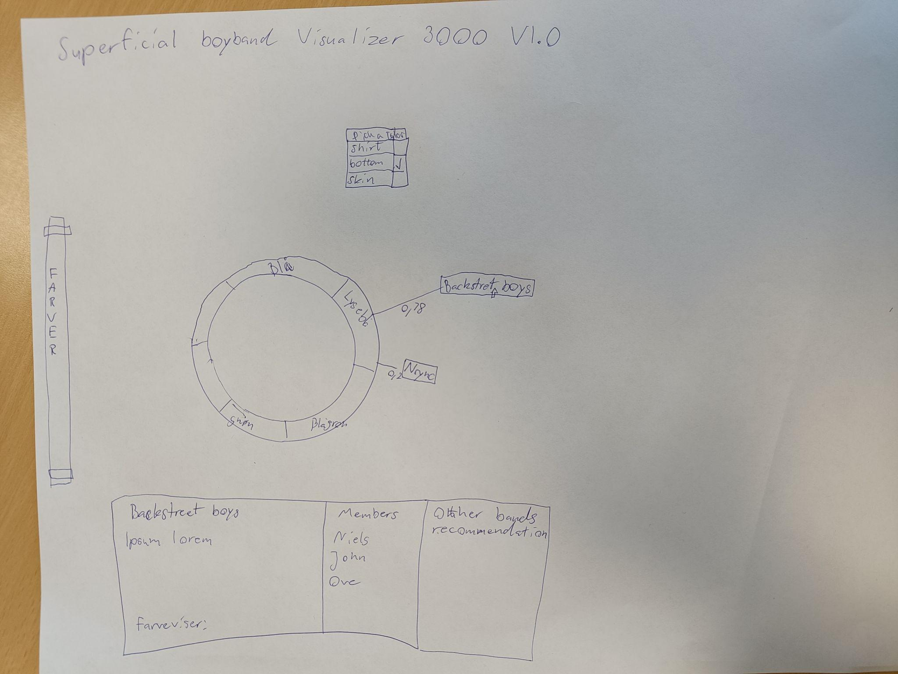
Refinement of the original sketch: use clothing fields for dress coordination. Its skin option would answer a separate descriptive question, not whether outfits match. Any similar-band suggestions would need an explicit comparison rule; they are optional, not part of the core interaction. Sketch names and scores are illustrative unless checked against the data.

Sketch B: Do larger boybands have more or less uniform recorded clothing colours?
Title: Band Size versus Colour Uniformity.
Overall layout: Five labelled arc regions organize bands of size 3, 4, 5, 6 and 7. Each band has a separate angular slot within its group and a point positioned radially by its score. A clothing selector sits above; a legend and selected-band details sit beside or below the chart.
Marks: Structural arc segments for size groups, radial stems with point endpoints for bands, concentric score guides, group labels and a member-details panel.
Channels: Angular region identifies band-size group; radial distance/line length encodes U; point fill identifies signature colour. Equal-sized points avoid confusing band size with point area. Labels show group sample size and exact values.
Radial geometry: Use five clearly separated group sectors and a common inner U = 0 baseline, with guides at 0.25, 0.5, 0.75 and 1. Sector width is layout space, not band size. Mark the boundary between 7 and 3 explicitly: band size is not cyclic.
Interaction: Switch bottom/shirt colour, select a size group to focus on its bands, and hover/focus or select a band for its score, colour counts and member swatches. Keep the 0-1 scale fixed when filtering and provide reset.
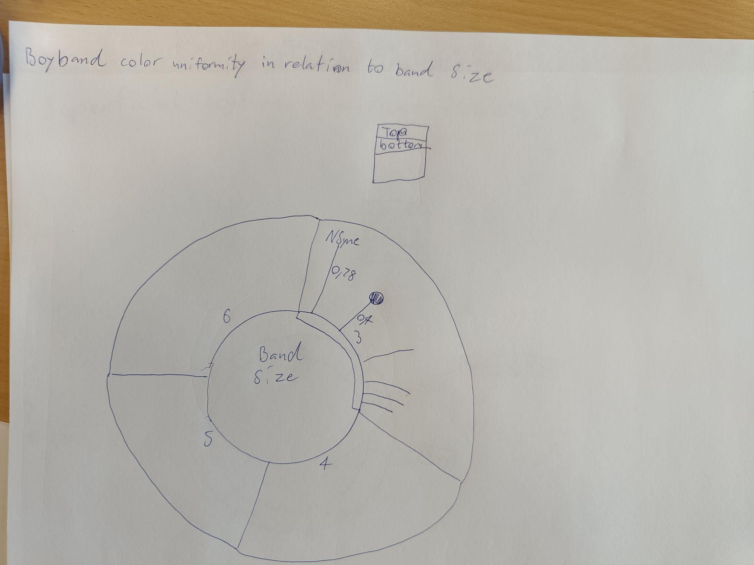

Sketch C: Which recorded colours are most common within each zodiac group? (Embedded wireframe below.)
Title: Boyband Colours across the Zodiac.
Overall layout: A wheel of 12 zodiac groups in annual order, with five rings for skin tone, hair colour, eye colour, shirt colour and bottom colour. The centre shows the included record count. A reading guide and a selected-sign member panel explain the rings.
Marks: Sector-shaped ring cells, sign labels, count labels and individual member swatches/cards in the detail view.
Channels: Sector angle encodes the group's share of records with known birth dates; ring position identifies the attribute; fill shows the most frequent recorded category for that attribute and sign. Text gives exact counts and category names; tied modes are labelled rather than assigned an arbitrary winner.
Radial geometry: Preserve the sketch's count-proportional wedges in cyclic sign order. The circle represents all 191 records with available birth dates, not the duration of a year; wedge widths are counts, not calendar intervals. Disclose the 43 excluded records.
Interaction: Hover/focus a sign for its count and attribute modes; select it to reveal individual member records and full category distributions. Highlight the selected wedge, mute the others and provide clear selection/reset controls.

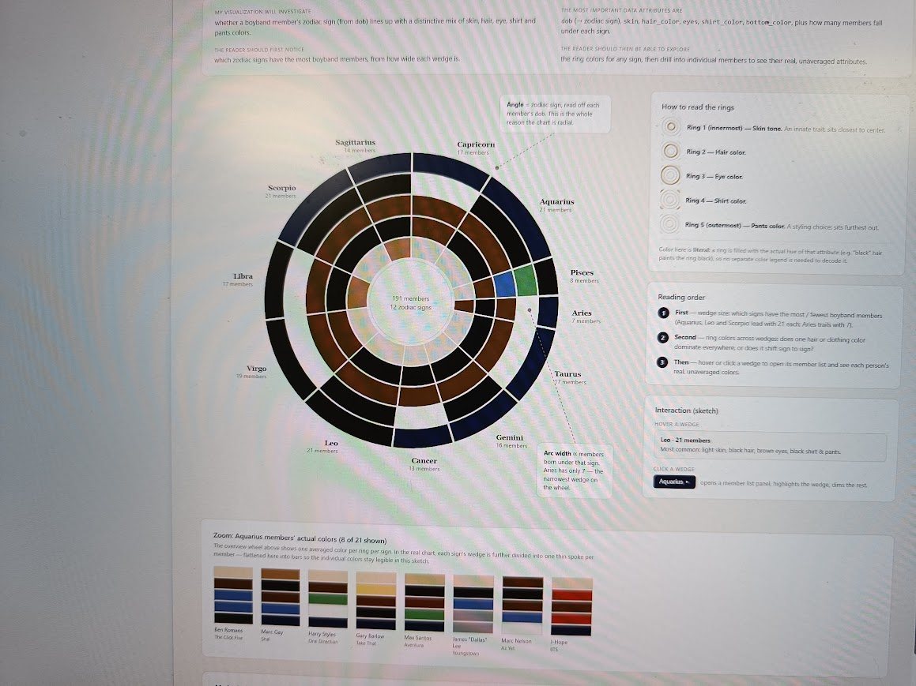
Refinement of the original wireframe: use the most frequent category, not an averaged colour; the image currently uses both descriptions. If modes tie, use a labelled tied/mixed cell and show all tied categories in details. Unknown values must remain visibly distinct from recorded colours. Compute each ring summary from its own known values and show its denominator.
The zodiac mapping will use explicitly documented conventional month/day boundaries; it is a grouping device, not an astrological explanation. The dataset does not show that a zodiac sign causes an appearance or predicts joining a band. Repeated artist records and different amounts of missing data limit interpretation.

5. CREATE VISUALIZATION IDEAS (2): MARKS AND CHANNELS

For each sketch, answer the following:

Sketch A
What are the marks? Arc regions represent signature-colour groups; radial lines and endpoints represent bands; labels and swatches show details.
What are the channels? Category -> angular region and labelled colour; uniformity -> radial position/line length; band identity -> text and selectable point.
What do they communicate? Which bands share a most-common recorded clothing colour, how consistently their members match, and which member-level observations explain the summary.

Sketch B
What are the marks? Arc regions represent band-size groups; one point and stem represent each band; circular guides provide the uniformity scale.
What are the channels? Band size -> labelled angular group; uniformity -> radial position/line length; signature colour -> point fill with text labels in the legend and details.
What do they communicate? The spread of uniformity scores within and between size groups. The intended task is to compare distributions and inspect exceptions, not to assume a correlation or imply causation.

Sketch C
What are the marks? Ring-sector cells represent an attribute summary within a zodiac group. Labels show signs and counts; member swatches show the underlying records.
What are the channels? Group count -> sector angle; attribute identity -> ring position; modal category -> labelled fill. Zodiac signs follow annual cyclic order, but angular widths represent record shares.
What do they communicate? The composition of known-date records by sign and the most frequent recorded categories in each group, with details revealing variation hidden by a mode.

Then compare the three alternatives:
A is best for browsing bands by recorded signature colour and inspecting how uniform they are. It uses proximity and similarity to group related bands, but can become crowded when many bands share black or navy blue. B is the clearest match to the selected question because it places individual band scores inside size groups; however, radial positions do not share the easily compared baseline of a Cartesian chart. Only two six-member bands and one seven-member band are available, so differences in those groups should not be generalised.
C has a natural cyclic ordering and a useful part-to-whole angle encoding, but it answers a different question. Its five rings are denser, modes hide variation, and 43 records lack birth dates. A and B have complete bottom-colour data. In all three designs, exact text, member details and labelled colours are needed because hue alone and radial estimates are not sufficiently precise.
Comparison outcome: keep all three alternatives for now. B is the strongest candidate for the current main question; A supports colour-led exploration; C supports a different calendar-group exploration. Use peer feedback before making the final implementation choice.

6. CREATE VISUALIZATION IDEAS (3): RADIAL GEOMETRY

Include radial geometry in your sketches.

Why are angles appropriate?
A: angles allocate separate regions to signature-colour categories, giving the ring a grouping role. Clothing colours do not form a natural cycle here; equal sectors are a layout choice, not a measure of colour difference. The justification is compact grouping and exploration, not greater comparison accuracy.
B: arcs organize discrete band-size groups. Band size is sequential, not cyclic, so the boundary between 7 and 3 must be explicit, with no connected trend line wrapping around it. The radial arrangement meets the assignment while retaining a fixed 0-1 score scale; an aligned dot plot would support more accurate comparison and should be acknowledged as an alternative.
C: signs have a cyclic annual order and the full circle represents all known-date records. Wedge angle is proportional to group count, so it supports part-to-whole reading. This preserves order but not calendar distance. Angles and unaligned radial positions are harder to estimate than common-scale positions, so labels and exact values remain necessary.

Include your marks and channels:
A/B: draw structural arcs, then separate radial lines and equal-sized point marks. Map U linearly to distance beyond a visible inner baseline; the points and thin lines encode position/length, not filled wedge area. Keep the same radial domain under filtering. C: ring-sector area marks use angular extent for record share, ring position for attribute identity and labelled fill for category.
Reading support: provide a title/question, a concise how-to-read guide, scale labels and a labelled colour key. Black, navy and similar shades need explicit names; white marks need an outline. Mark tied/mixed and unknown values without disguising them as a real colour. Use readable label orientation, spacing and detail-on-demand instead of overlapping labels. Check colour-deficiency and greyscale readability before submission.

7. CREATE VISUALIZATION IDEAS (4): INTERACTION

Choose one or more interactions:
A/B: clothing-attribute selection, category/size-group filtering, hover or keyboard focus for an exact-value tooltip, click or keyboard activation for persistent band details, and reset. C: hover/focus a sign for counts and modes, select it for member records and distributions, and clear the selection. Selection uses an outline as well as emphasis so it is not conveyed by colour alone.

Why do you want to include them in your visualization?
Filtering reduces clutter and supports browsing a subset. Attribute switching lets the reader test whether bottom-colour patterns also appear in shirts. Tooltips support exact lookup, while a persistent detail panel exposes the member-level evidence behind an aggregate. Reset preserves orientation and returns to a known starting point. These interactions answer questions rather than merely animate the chart.

Sketch the expected interaction in a wireframe.
Interaction wireframe, based on the embedded sketches: [title + question] -> [clothing selector where applicable + filters + Reset] -> [radial overview | legend and reading guide] -> [persistent detail panel below].
State 1, overview: all bands or all known-date zodiac groups are visible, with sample-size and missing-data notes. State 2, hover/focus: an outline highlights one mark and a tooltip shows its exact name, count and score or modes. The overview stays in place.
State 3, selected: keep the outline and populate the detail panel with member names, recorded colour labels/swatches, category counts and data coverage. In A/B show the pair counts behind U; in C show the selected sign and its full distributions. State 4, change attribute/filter: recompute the displayed summaries, keep the 0-1 scale for A/B, and make any cleared selection explicit. State 5, reset: restore the default attribute, full data and unselected overview.
These are planned states, not claims of implemented functionality. The existing drawings provide the page layout; this state sequence specifies what each control should do.

8. PEER FEEDBACK (11:20)

Pitch your idea to another group.
Status: peer feedback has not yet been supplied. The checks below are a review plan, not feedback from another group. After the pitch, record the reviewer's actual comments, the resulting design changes and the final design choice.

Review:
Is the visualization question clear? Pending peer review. Ask the reviewer to restate each question and identify which design answers the selected band-size question.
Are the marks meaningful? Pending peer review. Ask what one arc, point, line and ring cell represents without prompting.
Are the channels effective? Pending peer review. Ask the reviewer to identify a high- and low-uniformity band, read an exact value and distinguish colour categories using labels as well as hue.
How does the arc layout communicate? Pending peer review. Check that the reviewer does not read A/B as natural cycles or C's wedge widths as calendar durations.
Is the interaction helpful? Pending peer review. Ask the reviewer to select a band/sign, explain its underlying records, change an attribute and return to the overview.
What else should be improved? Pending peer review. Record actual comments about clutter, ties, missing values, small samples, legends and label readability, then note the changes made.
Theory used: Sessions 1-2 (What/Why/How, data types and encodings), Session 3 (grouping and aggregation), Session 4 (selection, filtering and details), Session 5 (exploratory questions and task abstraction), Session 6 (channel effectiveness, colour accessibility and Gestalt grouping), and the Session 7 radial notes/workshop slides. The accompanying handin3-plan.md links the source material and separates workshop work from the later implementation and reflection.

